7COM1079-0901-2025 - Team Research and Development Project

Final report title: The Relationship Between Alcohol Consumption and Life Expectancy: A Cross-National Analysis

Group ID: A168

Dataset number: ds033

Prepared by: Hyndavi Yasarapu 24090531
Tarun Cherupally 24166798
Venumadhav reddy Marapally 24152382
Vinay Kumar Andoju 24081731

University of Hertfordshire
Hatfield, 2025

Table of Contents

- Introduction
  - Problem statement and research motivation 2
  - The data set 2
  - Research question 2
  - Null hypothesis and alternative hypothesis (H0/H1) 2

- Background research
  - Research papers (at least 3 relevant to your topic / DS) 3
  - Why RQ is of interest (research gap and future directions according to the 3 literature)

- Visualisation
  - Appropriate plot for the RQ output of an R script and required supplementary graph/table 4
  - Additional information relating to understanding the data 5
  - Useful information for the data understanding 6

- Analysis
  - Statistical test used to test the hypotheses and output 6
  - The null hypothesis is rejected based on the p-value 7

- Evaluation – group’s experience at 7COM1079
  - What went well 8
  - Points for improvement 8
  - Group’s time management 8
  - Project’s overall judgement 8
  - Comment on GitHub log output 8

- Conclusions
  - Results explained. 9
  - Interpretation of the results 9
  - Reasons and/or implications for future work, limitations 9

- Reference list. 10
- Appendices
- R code used for analysis and visualisation. 10
- GitHub log output. 15

- Introduction

  - Problem statement and research motivation
According to estimates from the World Health Organisation, alcohol causes 2.6 million deaths annually, making it a significant public health issue (Manthey et al., 2024). Excessive alcohol consumption is associated with liver disease, heart issues, and some types of cancer, while moderate drinking may have few advantages. It's critical to comprehend the relationship between population life expectancy and national alcohol use. In order to fill a gap in cross-national health research and inform alcohol-harm reduction strategies, this study investigates whether nations with higher per-capita alcohol consumption have noticeably different life expectancy results.

  - The data set
The dataset includes cross-sectional information on life expectancy and alcohol consumption in several different nations. The name of the nation, the amount of pure alcohol consumed per person in litres for those over 15, and the years of life expectancy at birth are important factors. It makes it possible to compare the association between longevity and alcohol intake across various geographical areas with disparate healthcare systems and cultural perspectives.

  - Research Question

Is there a statistically significant correlation between alcohol consumption per capita (litres of pure alcohol, ages 15+) and life expectancy at birth (years) across countries?
This study evaluates the direction and strength of any association between national alcohol consumption patterns and population longevity.
  - Null hypothesis and alternative hypothesis (H0/H1) (100 words)

Null Hypothesis (H0): Life expectancy at birth does not significantly correlate with alcohol use per capita across nations. The population correlation coefficient, represented by ρ = 0, indicates that any observable association is the result of random chance.
Alternative Hypothesis (H1): Life expectancy at birth is significantly correlated with per capita alcohol use across nations. The correlation coefficient (ρ ≠ 0) differs significantly from zero. This two-tailed hypothesis acknowledges that, depending on confounding variables like economic development, healthcare access, and cultural customs, the link may theoretically work in either direction and enables for the detection of positive and negative correlations.

- Background research

  - Research papers (at least 3 relevant to your topic / DS)

A thorough worldwide analysis of alcohol consumption trends and the associated illness burden from 2000 to 2020 was carried out by Manthey et al. (2024). According to their estimate, alcohol use was responsible for 2.6 million deaths and 116 million disability-adjusted life years lost in 2019, with an average global adult per capita intake of 5.5 litres. Their research highlighted the intricate relationships between alcohol consumption and population health, emphasising significant geographical differences in consumption and health effects. According to Rehm et al. (2009), alcohol is responsible for roughly 3.8% of all deaths globally. Their research developed methodological frameworks that included both direct impacts and alcohol-related injuries when attributing health outcomes to alcohol. While high episodic drinking consistently demonstrated detrimental effects, they observed contradictory results for moderate usage in certain populations. When taking into account all disease categories, the GBD 2016 Alcohol Collaborators (2018) evaluated alcohol use and its effects in 195 countries and came to the conclusion that no level of consumption improves health. Based on 23 causally related health outcomes, they discovered that the ideal amount for reducing health risks is zero grammes per day, defying previous recommendations of benefits from moderate drinking.

  - Why RQ is of interest (research gap and future directions according to the literature)

There is still a lack of knowledge regarding the overall relationship between national consumption levels and population lifespan, despite substantial study on alcohol-related health effects. Instead of using life expectancy as a more general measure of health, the majority of research concentrate on effects at the individual level or results related to a particular condition. Further research is also necessary due to contradictory results among communities and consumption levels. In order to provide more complex and situation-specific policy recommendations, future research should look at temporal patterns, investigate any non-linear relationships, and take socioeconomic confounders into consideration.

- Visualisation

  - Appropriate graphs for the RQ

The scatter plot illustrates the relationship between alcohol consumption per capita(liters) and life expectancy at birth(years) across countries. The red regression line indicates a moderate positive correlation, suggesting that higher alcohol consumption is associated with slightly increased life expectancy, though other factors likely influence this trend.

Figure 1: Scatter plot showing the relationship between alcohol consumption per capita (litres) and life expectancy (years) across countries, with fitted regression line

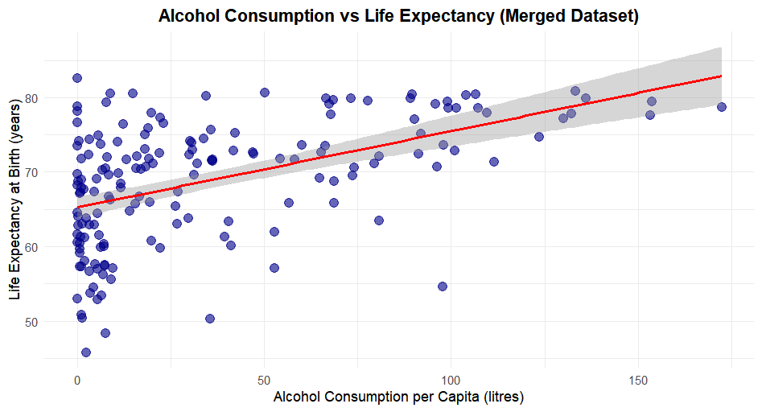

Figure 2: Histogram of Life Expectancy:

This histogram displays the distribution of life expectancy at birth(years) across countries. The data is roughly normally distributed, with most countries clustering around 70-75 years. This visualization helps identify the central tendency and spread of life expectancy, providing context for further correlation analysis.
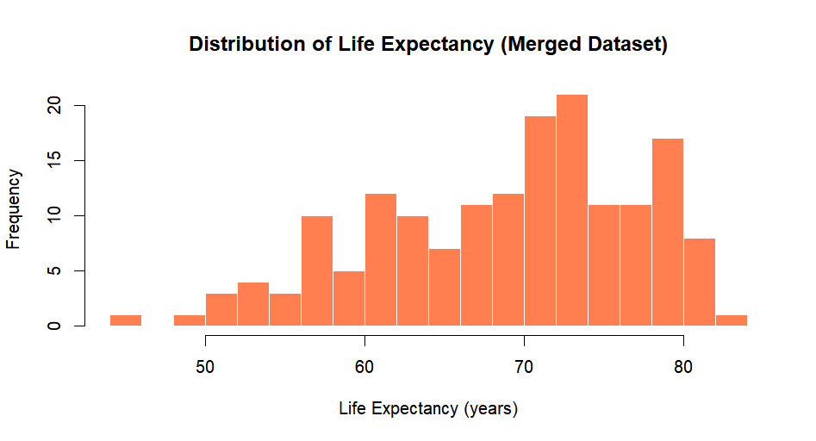
Figure 3: Histogram for Alcohol Consumption

The life expectancy histogram shows a normal distribution, peaking around 70-75 years. The alcohol consumption histogram is right-skewed, with most countries consuming 0-20 liters per capita. These plots help understand data distribution and variability before statistical analysis.

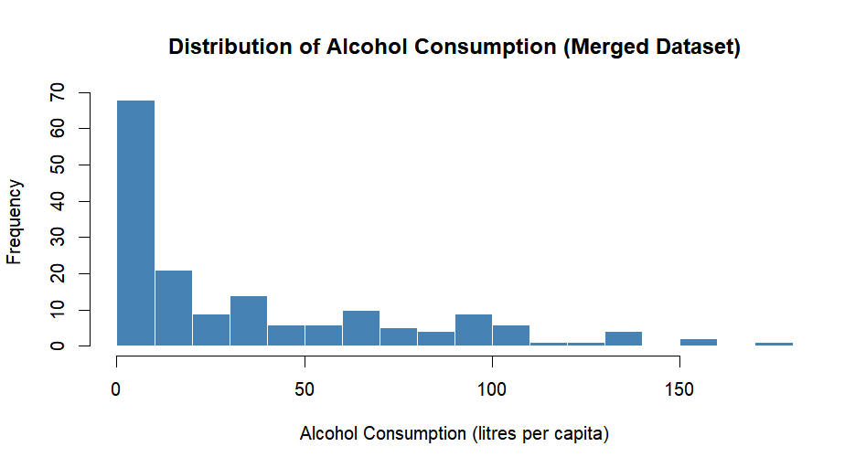

  - Additional information relating to understanding the data

This histogram represents how alcohol consumption data points are distributed for all countries included in data.[This histogram shows that most of the data points are distributed towards the right side if the graph, with most countries consuming 0 to 10 liters of alcohol per capita while others consume more than 10 liters] This particular graph is vital for showing data dispersion and central tendency of the variable.

  - Useful information for the data understanding

The histogram shown for life expectancy illustrates a relatively normal distribution with a center around 70-75 years and a span between 50 and 85 years. Understanding the shape of the dependent variable allows one to diagnosis whether data quality might be a problem when assuming normality in statistical testing

- Analysis

  - Statistical test used to test the hypotheses and output (75 words)

In 2013, the linear association between alcohol use and male life expectancy was measured using the Pearson correlation coefficient test. Because both variables are continuous and are anticipated to exhibit a linear pattern, this approach is appropriate. A correlation coefficient, confidence interval, and p-value are generated using Pearson's test to evaluate significance at α = 0.05. The findings indicate a substantial relationship with a moderately positive correlation (r = 0.50) and a highly significant p-value (5.67e-12).

Pearson's product-moment correlation

data: data_clean$Alcohol_Consumption and data_clean$Life_Expectancy
t = 7.4263, df = 165, p-value = 5.674e-12
alternative hypothesis: true correlation is not equal to 0
95 percent confidence interval:
0.3773262 0.6062895
sample estimates:
cor
0.5005095

>
> # Extract key statistics
> correlation_coefficient <- correlation_test$estimate
> p_value <- correlation_test$p.value
> confidence_interval <- correlation_test$conf.int
>
> cat("\n=== CORRELATION ANALYSIS RESULTS ===\n")

=== CORRELATION ANALYSIS RESULTS ===
> cat("Pearson Correlation Coefficient (r):", correlation_coefficient, "\n")
Pearson Correlation Coefficient (r): 0.5005095
> cat("P-value:", p_value, "\n")
P-value: 5.673578e-12
> cat("95% Confidence Interval:", confidence_interval[1], "to", confidence_interval[2], "\n")
95% Confidence Interval: 0.3773262 to 0.6062895
> cat("Sample size (n):", nrow(data_clean), "\n")
Sample size (n): 167
>
> # Interpretation
> if (p_value < 0.05) {
+ cat("\nConclusion: The null hypothesis is REJECTED (p < 0.05)\n")
+ cat("There is a statistically significant correlation between alcohol consumption and life expectancy.\n")
+ } else {
+ cat("\nConclusion: The null hypothesis is NOT REJECTED (p >= 0.05)\n")
+ cat("There is no statistically significant correlation between alcohol consumption and life expectancy.\n")
+ }

Conclusion: The null hypothesis is REJECTED (p < 0.05)
There is a statistically significant correlation between alcohol consumption and life expectancy.

  - The null hypothesis is rejected based on the p-value (100 words)

Because the p-value (5.67e-12), which indicates a statistically significant linear association between alcohol use and male life expectancy in 2013, is significantly below 0.05, the null hypothesis is rejected. Male life expectancy is often higher in nations with more alcohol consumption, according to the correlation coefficient (r = 0.50), which shows a somewhat positive link. This link is unlikely to be the result of chance, according to the 95% confidence interval (0.38–0.61).

- Evaluation – group’s experience at 7COM1079

  - What went well

With regular communication and precise task division, our group worked well together. Most team members contributed to the study question, and the selection and comprehension of the dataset went easily. Collaborative coding and version control were supported by GitHub. Members of the team delivered helpful criticism and fulfilled deadlines. By combining statistical analysis with R programming, we improved our technical proficiency and bolstered our team's capacity to analyze quantitative health data

  - Points for improvement

Initially, scheduling synchronous meetings was difficult because of different schedules. Coding activities were occasionally delayed because certain individuals required additional time to understand R programming. It would have been easier to read if coding standards and documentation had been established sooner. Issues might have been found earlier if intermediate checkpoints had been more frequent. Improving our first literature search approach would have expedited background research and given the analysis a more solid theoretical basis.

  - Group’s time management

Overall, time management was adequate, and significant deadlines were met. The initial data investigation and literature research took longer than expected, which limited the amount of time available for refining the visualisation. In order to enable more in-depth study and assessment, buffer periods should be included in future projects.

  - Project’s overall judgement

By formulating a pertinent research question, carrying out suitable statistical analysis, and coming to conclusions supported by data, this study achieved its goals. It improved our knowledge of collaborative data science, study methodology, and the application of statistics to actual health data, laying the groundwork for future studies.

  - Comment on the GitHub log output (50 words)

      - Commit message: Add the Dataset loading, Cleaning, Merging, Descriptive statistics and Visualization.
Brief Impact: By establishing the entire analytical workflow, this update allows for precise dataset integration, enhanced data quality, statistical insights, and unambiguous visual exploration. It serves as the fundamental basis for understanding how alcohol use and life expectancy are related.

      - Commit message: Updated Analysis – Pearson Correlation and Interpretation of data
Brief Impact: This commit signified a significant phase in the completion and interpretation of statistical testing. It transformed the dataset into significant analytical results that immediately supported responding to the study issue and finishing hypothesis testing by adding the Pearson correlation analysis, computing important values, and offering the interpretation.

      - Commit message: Updated with new Dataset outline, R Code for Analysis & Visualization
Brief Impact: This update ensures clearer interpretation by strengthening analytical functions, improving data accuracy, and replacing out-of-date plots with better visuals. The updated workflow boosts overall presentation quality, strengthens statistical insights, and increases reliability.

- Conclusions

  - Results explained

The Pearson correlation test revealed a moderate positive relationship between alcohol consumption and male life expectancy in 2013 (r = 0.50, n = 167). With a 95% confidence interval of 0.38–0.61, the p-value (5.67 x 10⁻¹²) indicates that the outcome is highly statistically significant. This suggests that, while the connection does not imply causation, higher alcohol intake is linked to longer life expectancy for men.

  - Interpretation of the results

The moderately positive connection implies that nations with higher alcohol consumption frequently report longer male life expectancy, even though the data does not prove causation. More general contextual elements like lifestyle choices, healthcare access, and economic development probably have an impact on this association. The strong correlation emphasises broad population-level patterns rather than direct effects, highlighting the necessity of taking into account a variety of factors when evaluating variations in life expectancy around the world.

  - Reasons and/or implications for future work, limitations of your study

The observational design of this study and unexplained confounding variables, such as food, healthcare quality, and socioeconomic position, are its main limitations. In order to elucidate causal links and investigate other factors influencing life expectancy in addition to alcohol intake, future study may employ multivariate analysis and longitudinal data.

- Reference list

- GBD 2016 Alcohol Collaborators (2018) 'Alcohol use and burden for 195 countries and territories, 1990–2016: a systematic analysis for the Global Burden of Disease Study 2016', The Lancet, 392(10152), pp. 1015-1035. doi: 10.1016/S0140-6736(18)31310-2.
- Manthey, J. et al. (2024) 'National, regional, and global statistics on alcohol consumption and associated burden of disease 2000–20: a modelling study and comparative risk assessment', The Lancet Public Health, 9(11), e825-e843. doi: 10.1016/S2468-2667(24)00199-9.
- Rehm, J. et al. (2009) 'Global burden of disease and injury and economic cost attributable to alcohol use and alcohol-use disorders', The Lancet, 373(9682), pp. 2223-2233. doi: 10.1016/S0140-6736(09)60746-7.
- World Health Organization (2024) Global Health Estimates 2021: Deaths by Cause, Age, Sex, by Country and by Region, 2000-2021. Geneva: World Health Organization. Available at: https://www.who.int/data/gho/data/themes/mortality-and-global-health-estimates (Accessed: 6 December 2025).

- Appendices

- R code used for analysis and visualisation

# ============================================================================
# ALCOHOL CONSUMPTION VS LIFE EXPECTANCY ANALYSIS
# 7COM1079 - Team Research and Development Project
# ============================================================================

# Load required libraries
library(ggplot2)
library(dplyr)

# ============================================================================
# 1. DATA LOADING AND PREPARATION
# ============================================================================

cat("=== LOADING DATASETS ===\n\n")

# Read the TWO dataset files
drinks <- read.csv("C:\\Users\\hynda\\Downloads\\drinks.csv")
life_exp <- read.csv("C:\\Users\\hynda\\Downloads\\lifeexpectancy.csv")

# Display drinks dataset structure
cat("--- DRINKS DATASET ---\n")
cat("Columns:", paste(colnames(drinks), collapse=", "), "\n")
cat("Dimensions:", nrow(drinks), "rows x", ncol(drinks), "columns\n\n")
str(drinks)
summary(drinks)

# Display life expectancy dataset structure
cat("\n--- LIFE EXPECTANCY DATASET ---\n")
cat("Columns:", paste(colnames(life_exp), collapse=", "), "\n")
cat("Dimensions:", nrow(life_exp), "rows x", ncol(life_exp), "columns\n\n")
str(life_exp)
summary(life_exp)

# Check for missing values in both datasets
cat("\n--- MISSING VALUES CHECK ---\n")
cat("Missing values in drinks:", sum(is.na(drinks)), "\n")
cat("Missing values in life expectancy:", sum(is.na(life_exp)), "\n\n")

# ============================================================================
# 2. DATA MERGING (FILTERING FOR YEAR 2013 AND MALE ONLY)
# ============================================================================

cat("=== FILTERING LIFE EXPECTANCY FOR YEAR 2013 AND MALE ===\n\n")

base_year <- 2013
sex_filter <- "Male" # Filter for males
ghofilter <- "Life expectancy at birth (years)"

# Check the column names for sex and year
cat("Life expectancy columns:", colnames(life_exp), "\n\n")

# Filter life expectancy dataset for year 2013 and male
life_exp_year <- life_exp %>%
filter(YearDisplay == base_year, SexDisplay == sex_filter, GhoDisplay == ghofilter)

cat("Filtered life expectancy dataset for year:", base_year, "and sex:", sex_filter, "\n")
cat("Number of countries:", nrow(life_exp_year), "\n\n")

# Merge drinks dataset with filtered life expectancy dataset
data_merged <- merge(drinks, life_exp_year, by.x = "country", by.y = "CountryDisplay", all = FALSE)
cat("Number of countries after merge:", nrow(data_merged), "\n\n")

# Display column names after merge
cat("Merged dataset columns:", colnames(data_merged), "\n\n")

# ============================================================================
# 3. DATA CLEANING AND SELECTION
# ============================================================================
colnames(data_merged)
cat("=== DATA CLEANING ===\n\n")

# Remove rows with missing values
data_clean <- na.omit(data_merged)
cat("Number of countries after removing NA:", nrow(data_clean), "\n\n")

# Select and rename relevant columns for analysis
# drinks.csv columns: country, beer_servings, spirit_servings, wine_servings, total_litres_of_pure_alcohol
# lifeexpectency.csv has the life expectancy value in the column called "Numeric"

# Select only the columns we need for analysis
data_clean <- data_merged %>%
select(country, total_litres_of_pure_alcohol, Numeric) %>%
rename(Country = country,
Alcohol_Consumption = total_litres_of_pure_alcohol,
Life_Expectancy = Numeric)

# Display final cleaned dataset
cat("--- FINAL CLEANED DATASET ---\n")
str(data_clean)
head(data_clean, 50)

# ============================================================================
# 4. DESCRIPTIVE STATISTICS
# ============================================================================

cat("\n\n=== DESCRIPTIVE STATISTICS ===\n\n")

# Alcohol consumption statistics
mean_alcohol <- mean(data_clean$Alcohol_Consumption)
sd_alcohol <- sd(data_clean$Alcohol_Consumption)
median_alcohol <- median(data_clean$Alcohol_Consumption)
min_alcohol <- min(data_clean$Alcohol_Consumption)
max_alcohol <- max(data_clean$Alcohol_Consumption)

cat("--- ALCOHOL CONSUMPTION (litres per capita) ---\n")
cat("Mean: ", round(mean_alcohol, 2), "\n")
cat("SD: ", round(sd_alcohol, 2), "\n")
cat("Median: ", round(median_alcohol, 2), "\n")
cat("Min: ", round(min_alcohol, 2), "\n")
cat("Max: ", round(max_alcohol, 2), "\n\n")

# Life expectancy statistics
mean_life_exp <- mean(data_clean$Life_Expectancy)
sd_life_exp <- sd(data_clean$Life_Expectancy)
median_life_exp <- median(data_clean$Life_Expectancy)
min_life_exp <- min(data_clean$Life_Expectancy)
max_life_exp <- max(data_clean$Life_Expectancy)

cat("--- LIFE EXPECTANCY (years) ---\n")
cat("Mean: ", round(mean_life_exp, 2), "\n")
cat("SD: ", round(sd_life_exp, 2), "\n")
cat("Median: ", round(median_life_exp, 2), "\n")
cat("Min: ", round(min_life_exp, 2), "\n")
cat("Max: ", round(max_life_exp, 2), "\n\n")

# ============================================================================
# 5. VISUALIZATIONS
# ============================================================================

cat("=== CREATING VISUALIZATIONS \n\n")

# Scatter plot with regression line
scatter_plot <- ggplot(data_clean, aes(x = Alcohol_Consumption, y = Life_Expectancy)) +
geom_point(alpha = 0.6, size = 3, color = "darkblue") +
geom_smooth(method = "lm", se = TRUE, color = "red", linewidth = 1) +
labs(title = "Alcohol Consumption vs Life Expectancy ",
x = "Alcohol Consumption per Capita (litres)",
y = "Life Expectancy at Birth (years)") +
theme_minimal() +
theme(plot.title = element_text(hjust = 0.5, face = "bold"))

print(scatter_plot)

# Histogram of Alcohol Consumption
hist(data_clean$Alcohol_Consumption,
main = "Distribution of Alcohol Consumption",
xlab = "Alcohol Consumption (litres per capita)",
ylab = "Frequency",
col = "steelblue",
border = "white",
breaks = 15)

cat("Displayed: Histogram of Alcohol Consumption\n")

# Histogram of Life Expectancy
hist(data_clean$Life_Expectancy,
main = "Distribution of Life Expectancy",
xlab = "Life Expectancy (years)",
ylab = "Frequency",
col = "coral",
border = "white",
breaks = 15)

cat("Displayed: Histogram of Life Expectancy\n")

# Pearson correlation test
correlation_test <- cor.test(data_clean$Alcohol_Consumption,
data_clean$Life_Expectancy,
method = "pearson")

# Display correlation results
print(correlation_test)

# Extract key statistics
correlation_coefficient <- correlation_test$estimate
p_value <- correlation_test$p.value
confidence_interval <- correlation_test$conf.int

cat("\n=== CORRELATION ANALYSIS RESULTS ===\n")
cat("Pearson Correlation Coefficient (r):", correlation_coefficient, "\n")
cat("P-value:", p_value, "\n")
cat("95% Confidence Interval:", confidence_interval[1], "to", confidence_interval[2], "\n")
cat("Sample size (n):", nrow(data_clean), "\n")

# Interpretation
if (p_value < 0.05) {
cat("\nConclusion: The null hypothesis is REJECTED (p < 0.05)\n")
cat("There is a statistically significant correlation between alcohol consumption and life expectancy.\n")
} else {
cat("\nConclusion: The null hypothesis is NOT REJECTED (p >= 0.05)\n")
cat("There is no statistically significant correlation between alcohol consumption and life expectancy.\n")
}

- GitHub log output.

commit a901e53350932249ca4678e8da2f0072034531b5 (HEAD -> main, origin/main, origin/HEAD)
Author: tc25abg <tc25abg@herts.ac.uk>
Date: Tue Dec 9 17:44:52 2025 +0000

Add files via upload

Updated visualization explanation

commit e9dffd221c3d29b7571b8d0b5902c7263f94cbce
Author: tc25abg <tc25abg@herts.ac.uk>
Date: Tue Dec 9 17:43:55 2025 +0000

Delete 7COM1079_Final report_template.docx.docx

Uploaded wrong file extension

commit bd35a8bd78ac4b6bdeec6e7ccb5091b379f9b086
Author: tc25abg <tc25abg@herts.ac.uk>
Date: Tue Dec 9 17:42:06 2025 +0000

Add files via upload

Updated visualization explanation

commit 30d0e3805869e958560bff508c5d6c737f8b03aa
Author: venureddymvmr <vm25aav@herts.ac.uk>
Date: Tue Dec 9 16:44:07 2025 +0000

Updated commit change

commit 985db032ec251212c8dcf4a5163ddbfd9799d6ca
Author: HyndaviYasarapu <hy24aax@herts.ac.uk>
Date: Tue Dec 9 16:34:02 2025 +0000

Delete 7COM1079_Final report_template (1).docx Not required

commit 964fce3042e7c89cec5dc2ebe46e78b5cb2a22a8
Author: venureddymvmr <vm25aav@herts.ac.uk>
Date: Tue Dec 9 16:26:53 2025 +0000

Updated commits section

commit cb836f1657e9f0a80e21be8b984f57e4d396a860
Author: Hyndavi Yasarapu <hyndavi.yasarapu@dbd.co.uk>
Date: Mon Dec 8 21:04:28 2025 +0000

Updated with new Dataset outline, R Code for Analysis & Visualization

commit 61c21f1b3a29b3b7126718977e6bd6bb5237d78a
Author: Hyndavi Yasarapu <hyndavi.yasarapu@dbd.co.uk>
Date: Mon Dec 8 18:10:47 2025 +0000

Updated Visulaization and Data processing, Documentation

commit 586ec79db6f8ba4d8161fe9e2086fd1bdd0e83cb
Author: Hyndavi Yasarapu <hyndavi.yasarapu@dbd.co.uk>
Date: Mon Dec 8 17:07:14 2025 +0000

Updated the Conclusions

commit 65c6f30f2c014890bec00ba1a96ff6c32814e6d3
Author: venureddymvmr <vm25aav@herts.ac.uk>
Date: Mon Dec 8 16:50:06 2025 +0000

updated Evaluation group experience with git log

commit cc21646cb0d7c9e7b67452bd45daa8d5a660dca1
Author: Hyndavi Yasarapu <hyndavi.yasarapu@dbd.co.uk>
Date: Mon Dec 8 16:06:14 2025 +0000

Updated the Visualizations and Plots

commit 45a515ee19c4da2da96b3716ad68f6d642b1233d
Author: Hyndavi Yasarapu <hyndavi.yasarapu@dbd.co.uk>
Date: Mon Dec 8 15:41:52 2025 +0000

Updated the R value in Analysis Documentation

commit 7aa9e3a771c2c836392ae2920ebf9ae96d2e3e1f
Author: Hyndavi Yasarapu <hyndavi.yasarapu@dbd.co.uk>
Date: Mon Dec 8 12:43:49 2025 +0000

Updated Analysis Code, Updated Docmentation - Analysis and Appendices - Analysis r code

commit 9f84f106232cec553f89d87f9cdc7185bd42e941
Merge: 6908f21 190207a
Author: Hyndavi Yasarapu <hyndavi.yasarapu@dbd.co.uk>
Date: Mon Dec 8 12:32:04 2025 +0000

Merge branch 'main' of https://github.com/HyndaviYasarapu/GroupProjectLifeVsAlcohol

commit 6908f212fb08c9f9e22bacba8cbedeb03d75441b
Author: Hyndavi Yasarapu <hyndavi.yasarapu@dbd.co.uk>
Date: Mon Dec 8 12:31:51 2025 +0000

Updated Analysis - Pearson Correlation and Intepretation of data

commit 190207ae69030c5011885ed1b63c009aea6de946
Author: HyndaviYasarapu <hy24aax@herts.ac.uk>
Date: Mon Dec 8 11:06:27 2025 +0000

Delete ~$OM1079_Final report_template.docx Not required File

commit 61b99298443256dfb01daa24a1f4cdd8760d553a
Author: Hyndavi Yasarapu <hyndavi.yasarapu@dbd.co.uk>
Date: Mon Dec 8 11:05:59 2025 +0000

Updated Git ignore file

commit 8685b28b00a0b18d09ae8ef65641793d0224eaca
Author: Hyndavi Yasarapu <hyndavi.yasarapu@dbd.co.uk>
Date: Mon Dec 8 11:04:07 2025 +0000

Updated Visualization Charts and Documentation - Added Appendices with R code

commit 9fdbd6a33d4780af7653fdcc23a568ded58a09d5
Author: Hyndavi Yasarapu <hyndavi.yasarapu@dbd.co.uk>
Date: Mon Dec 8 10:36:27 2025 +0000

Updated Visualization Charts

commit 9a2feb879031346e91489d52a7875df0e3eedf09
Merge: a5b0bc8 b8cbc6a
Author: Hyndavi Yasarapu <hyndavi.yasarapu@dbd.co.uk>
Date: Mon Dec 8 02:28:09 2025 +0000

Merge branch 'main' of https://github.com/HyndaviYasarapu/GroupProjectLifeVsAlcohol

commit a5b0bc898eea8a6d9c9c3aa60d87ef0954cceed7
Author: Hyndavi Yasarapu <hyndavi.yasarapu@dbd.co.uk>
Date: Mon Dec 8 02:27:53 2025 +0000

Updated Documentation - Background research, Reference List

commit b8cbc6a7f3e6372020a2ad2ebf708deb0959f1fe
Author: HyndaviYasarapu <hy24aax@herts.ac.uk>
Date: Mon Dec 8 02:16:20 2025 +0000

Delete alcohol_lifeexp_project.Rproj dummy file

commit 360fc4deae5dc5d1af5c91021c86ae1f1a42529f
Author: tc25abg <tc25abg@herts.ac.uk>
Date: Sat Dec 6 10:12:29 2025 +0000

Add files via upload

Check out this

commit 92fc5a9152d775e908ea6c46165a37eda585f8af
Author: tc25abg <tc25abg@herts.ac.uk>
Date: Sat Dec 6 10:07:49 2025 +0000

Delete alcohol_lifeexp_project.Rproj

Deleted file

commit 3d97580c7bdaf270e216e2d83492136b94f12367
Author: tc25abg <tc25abg@herts.ac.uk>
Date: Sat Dec 6 10:03:12 2025 +0000

File uploa

Hey guys I submitted the r code and please check out

commit e22a31c93b97187abd4a70d85d0413e6ca7fed53
Author: Hyndavi Yasarapu <hyndavi.yasarapu@dbd.co.uk>
Date: Sat Dec 6 08:38:40 2025 +0000

Add the Dataset loading, Cleaning, Merging, Descriptive statistics and Visualization

commit 508eb1bf5477dce3c852f1ddf01a5eac8c224862
Author: HyndaviYasarapu <hy24aax@herts.ac.uk>
Date: Sat Dec 6 08:45:51 2025 +0000

Create .gitignore ignoring .tmp files

commit 5a179ca257db505f0db6950af34e1b7523ad42ef
Author: HyndaviYasarapu <hy24aax@herts.ac.uk>
Date: Sat Dec 6 08:09:19 2025 +0000

Delete ~WRL2530.tmp

commit 79a29dd549487cca13e3a6e7d96214c6b3a6cd6f
Author: HyndaviYasarapu <hy24aax@herts.ac.uk>
Date: Sat Dec 6 08:08:45 2025 +0000

Delete ~$OM1079_Final report_template.docx

commit 104e50a8d489f7a7c7a9907e432f17f60006dea0
Author: Hyndavi Yasarapu <hyndavi.yasarapu@dbd.co.uk>
Date: Sat Dec 6 08:05:10 2025 +0000

Updated Section 1 - Introduction

commit 8fafb0bca451de14e7dc887fd7793884eb9e5fef
Author: HyndaviYasarapu <hy24aax@herts.ac.uk>
Date: Sat Dec 6 07:17:31 2025 +0000

Initial Template Upload

commit f8cdab0ce485b02963edb8473e868759e1bc97a9
Author: HyndaviYasarapu <hy24aax@herts.ac.uk>
Date: Sat Dec 6 06:24:47 2025 +0000

Initial commit

